Software required: Excel

You are going to produce a pie chart using an Excel spreadsheet.
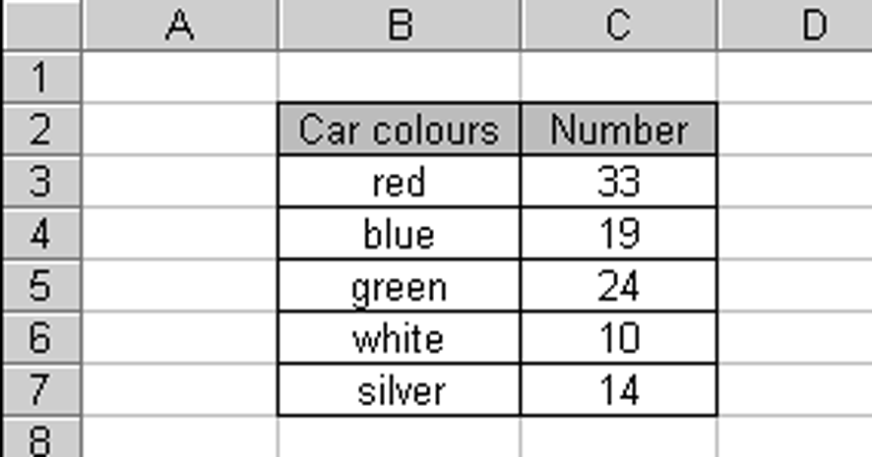

Follow these steps in the Chart Wizard:

1 Choose Pie Chart.
2 Click Next.
3 Set titles:
◆ Enter the title:
Car colours
◆ Turn legend off.
◆ Choose labels to show percentages.
4 Make the chart an object in the sheet.
To complete your pie chart.
◆ Select each sector in turn, and give it the correct colour.

1 Produce a pie chart for each of these sets of data:
Flavour | Votes |  | TV hours | People |  | Countries visited | People
Beef | 4 |  | Less than 1 | 2 |  | France | 9
Cheese | 7 |  | 1 – 2 | 4 |  | Spain | 12
Plain | 5 |  | 2 – 3 | 5 |  | Italy | 2
Salt & Vinegar | 12 |  | 3 – 4 | 3 |  | USA | 3
 |  |  | More than 4 | 2 |  | Ireland | 4
 |  |  |  |  |  | Other | 6
At step 3 of the Chart Wizard:
◆ Make up a suitable title for each of your charts.
◆ Show labels and percentages.
2 This diagram shows the first table of data in question 1 on a 3-D pie chart.
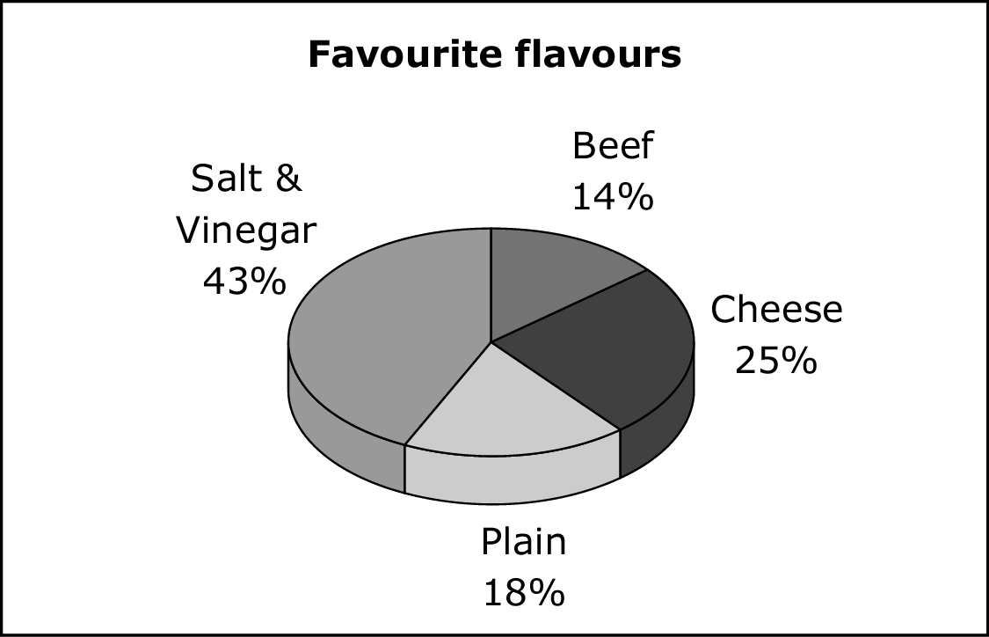
a Make a similar chart for each of the other tables of data in question 1.
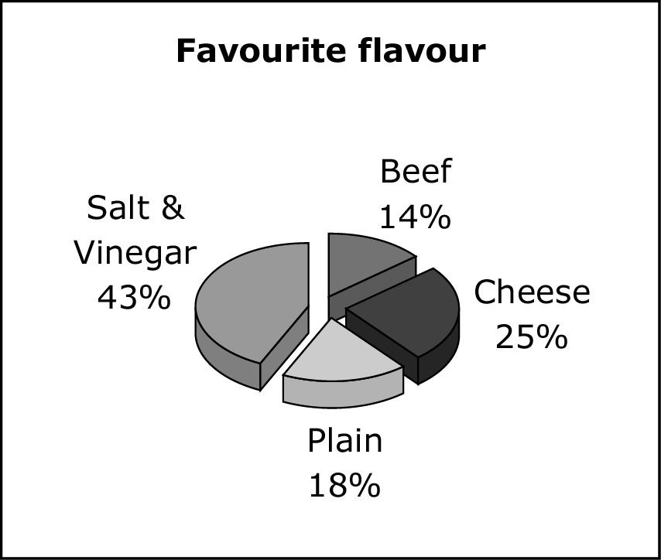
b Do 3-D pie charts look better than 2-D charts?
Are they easier to read, or harder?
3 This is an exploded 3-D pie chart.
Turn the data in the table into:
◆ an ‘ordinary’ 2-D pie chart
◆ a 3-D pie chart
◆ an exploded 3-D pie chart
People in car | Number of cars
1 | 19
2 | 12
3 | 7
4 | 2

Which one of these three charts shows the data most clearly?
1 Here is the introduction to an article in a school magazine.
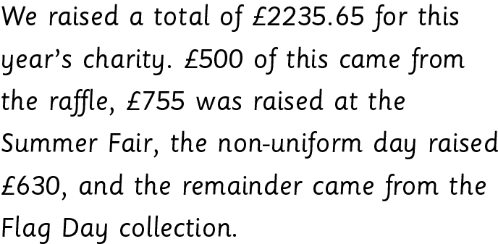
Type this section of the article into a word-processing program.
Give your document a suitable title.
Create a pie chart to represent this data in a spreadsheet, then copy and paste the pie chart into
the article.
2 David is an office manager. He receives this memo from the head of the IT department.
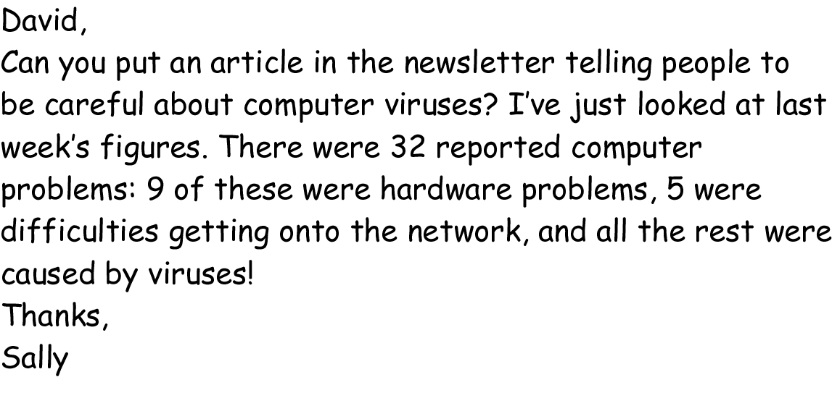
Write an article for the newsletter, illustrating it with a pie chart.
3 This pie chart featured in an advert for ‘Purrfection’ cat food.
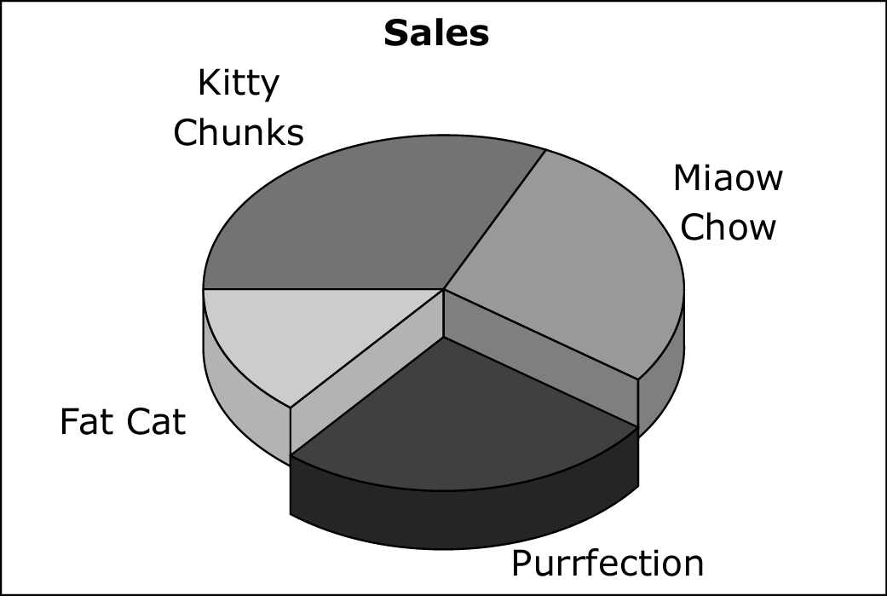
The manufacturers of ‘Miaow Chow’ want to complain that the advert is unfair.
The actual market share figures, which the advert is based on, are: Kitty Chunks 32%,
Miaow Chow 28%, Purrfection 26% and Fat Cat 14%.
Write a letter of complaint from the Miaow Chow company to the makers of Purrfection.
Illustrate your letter with pie charts.

