Question 1

Calculate, giving your answer in standard form correct to 3 significant figures.

1.52 × 10⁵ - 4.6 × 10⁴
4.56 × 10⁻²
[4]

Question 2

Natalie measured the distance between two points on a map.
The distance she measured was 5 cm correct to the nearest centimetre

(a) Write down the
i) least upper bound of the measurement
ii) greatest lower bound of the measurement

The scale of the map is 1 to 20 000

(b) Work out the actual distance in real life between the upper and lower bounds. Give your answer in kilometres.
[4]

Question 3

Use a trial and improvement method to solve the equation
x³ - x = 15

Complete the working below and find a solution correct to one decimal place.
[3]

Question 4

(a) Complete the table of values for the graphs of
y = x³ - 2 and
y = 3x² + 3x -6.

(b) i) Use the graph paper on the following page to draw the graphs of
y = x³ - 2 and y = 3x² + 3x - 6.

ii) Use your graph to solve the equation x³ - 3x² - 3x + 4 = 0.

[3]

Question 5

Solve the simultaneous equations
2x + 6y = 17
3x - 2y = 20
[4]

Question 6

i) Solve the inequality 3n > -8.

ii) Write down the smallest integer which satisfies the inequality 3n > -8.
(2 marks)

[2]

Question 7

Each of the equations in the table represents one of the graphs A to F.

Write the letter of each graph in the correct place in the table.

(3 marks)

[3]

Question 8

Sharon has 12 computer discs.
Five of the discs are red.
Seven of the discs are black.
She keeps all the discs in a box.
Sharon removes one disc at random. She records its colour and replaces it in the box.
Sharon removes a second disc at random, and again records its colour.

(a) Complete the tree diagram. (2 marks)

(b) Calculate the probability that the two discs removed
i) will both be red, (2 marks)
ii) will be different colours. (3 marks)

[7]

Question 9

(a) Reflect shape S in the line x = 0. Label the new shape T.

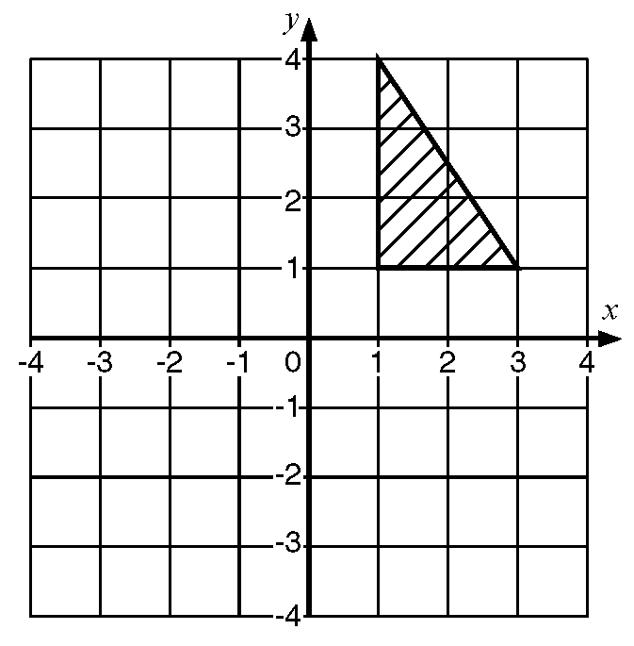

(b) Rotate the new shape T through an angle of 90º anticlockwise using (0, 0) as
the centre of rotation. Label the new shape U.

(c) Describe fully the single transformation that will move shape U back onto
shape S.
[6]

Question 10

(a) Use the table to calculate an estimate of the mean for her results.

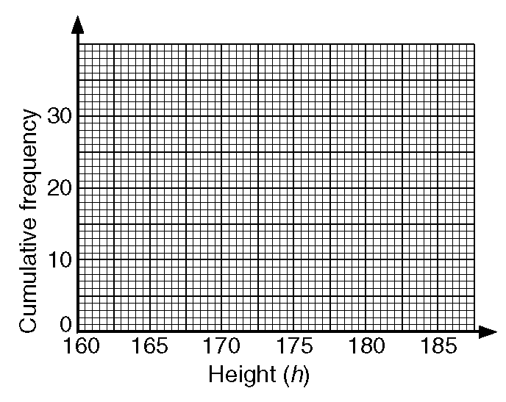

(c) Use the cumulative frequency graph to calculate i) the median, and ii) the
interquartile range of the data

[12]
Total = 48

