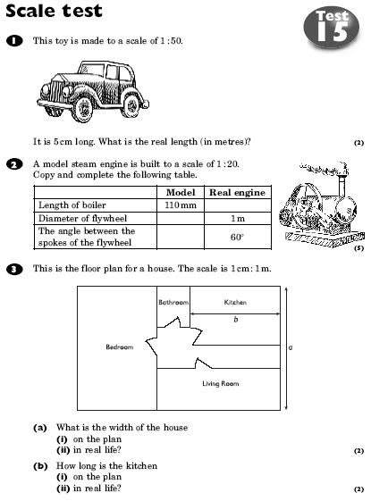 | 8.
  4 | a | Use a ruler and compasses to construct a triangle ABC with  AC = 10 cm, AB = 12 cm and angle BAC = 50°.
   | b | Measure the sizes of:  i angle ACB ii angle ABC
  5. The diagram shows a 3-D shape.
  Draw the view of this shape when it is looked at as a side
  elevation, in the direction of y .
  6 | Convert to cm:
   | a | 5 metres
   | b | 840 mm
  7 | Change
   | a | 100 m to cm
   | b | 1 km to m
   | c | 5000 mm to m.
  Construct this quadrilateral:
  Not drawn to scale

